

**MUHAMMAD IBRAHIM WARRAICH**

**SAP ID:46935**

**ASSIGNMENT NO 4**

**CLASSES AND INHERITENCE THEROY**:

**SINGLE CLASS INHERITENCE:**

The inheritance in which a single derived class is inherited from a single base class is known as the Single Inheritance. It is the simplest among all the types of inheritance since it does not include any kind of inheritance combination or different levels of inheritance.

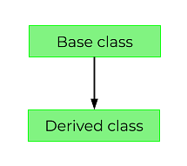

**MULTIPLE CLASS INHERITENCE:**

Multiple inheritance is a feature of some object-oriented computer programming languages in which an object or class can inherit features from more than one parent object or parent class. It is distinct from single inheritance, where an object or class may only inherit from one particular object or class.

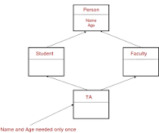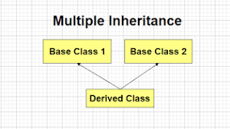

**MULTILEVEL CLASS INHERITENCE:**

The multi-level inheritance includes the involvement of at least two or more than two classes. One class inherits the features from a parent class and the newly created sub-class becomes the base class for another new class.



**HYBRID INHERITENCE:**

The process of combining more than one type of Inheritance together while deriving subclasses in a program is called a Hybrid Inheritance. Hybrid in C++ follows the following pattern - Multiple Inheritance, Single Inheritance, and Hierarchical Inheritances are combined together.

Class A as Animal Class, Class B as Mammals, Class C as Herbivores, Class D as Cow. Mammals can be derived from Animal class, and Cow is a combination of Herbivores and Mammals. This relationship well defines the combination of Multiple Inheritance and Single Inheritance.



